Company Name
Invoicing Address
Contact Name |  |  |  |  | Contact No.
Email Address
Purpose of Room Hire
Event Date(s) |  |  |  |  | Arrival Time
No. of Attendees |  |  |  |  | Start Time
Technician requirements | Please specify whether you need West Studios, Chesterfield College to provide a Technician. |  |  |  | End Time
Room Layout | Theatre Style | 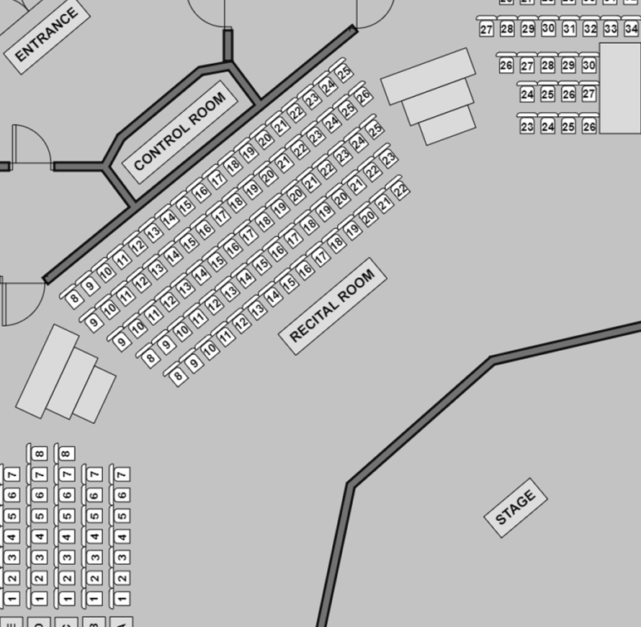
Additional Room(s) Required? | Yes/No | Requirements: |  | Include number of guests and how long the additional room is required for.  *PLEASE NOTE – Additional rooms are not included within the Recital Room Hire cost*
Recital Room Hire | Time Period |  | Cost |  | Total No. of hours | Start Time | End Time
 | Half Day |  | £300
 | Full Day |  | £500
 | Hourly |  | £100
Additional Comments
(customer catering, access requirements)
Terms and Conditions
Health and Safety
On arrival you must report to West Studios reception and sign in as a visitor. You are to remain on the ground floor of Chesterfield College West Block, known as West Studios, until a member of the team escorts you across to the recital room. You are to remain within the rooms allocated to your booking which you will be shown by a member of the West Studios/Chesterfield College Team. If you need to access any other areas of the college’s premise then please ask a member of the team for assistance as you will need a member of staff with an ID card to access buildings.
When you hear the fire alarm, you must immediately vacate the premises and go to the fire assemble point which is located in the West Studios Car Park.
In the event of first aid being required please let a member of the West Studios team know so they’re able to contact the college’s first aiders.
Insurance & Risk Assessment
Where the hire of rooms and / or space are for the purpose of providing a service or activity to other persons, those hiring the room shall produce appropriate Public Liability Insurance cover to West Studios before the hire commences. Those hiring the room must complete a risk assessment for the booking taking place and provide this to West Studios prior to the booking so it can be reviewed by the college’s Safety, Health & Environment department.
Confirmation
Final confirmation of the booking with the deposit invoice, will be sent from West Studios via email.
Booking Quote
The quote provided after you return this form will be the amount you are invoiced for unless you add any additional requirements to your booking. If you do add any additional requirements and this affects the quoted price you will be notified and a new quoted price will be supplied to you. The venues staffing charges are not included on this form but may apply depending on when your booking takes place. Our staffing charges will be included within the final quoted price. Upon receiving the quote you have 5 working days to confirm your booking until the quote is invalid.
Payment
Once we have received final confirmation, a deposit invoice totalling 20% of the full booking amount will be raised for payment. The Deposit payment is non-refundable.
A final invoice for the remaining amount will be raised and sent to the client within 10 working days before the event taking place. Payment is to be made in full and using the account reference quoted at the top of the invoice by either cheque or BACS. Details of payment methods will be outlined on the invoice.
Cancellation
Cancellations must be confirmed in writing at least 5 working days prior to the meeting taking place. If cancelled within 2 working days of the booking, full payment is still due.
Damages
Any damages to West Studios equipment/property will be the responsibility of the organiser and charges may occur, dependant on the severity of the damage caused.
Data Protection
In accordance with GDPR and the Data Protection Act 2018 the data you have provided will be stored safely and securely in our booking system. The purpose of this data is for you to access room hire from Chesterfield College Group West Studios. Your records are completely confidential and only Chesterfield College staff will have access to them. No information will be shared with third parties without prior agreement. For the purpose of room bookings Chesterfield College will store your information for 12 months. To view your rights as the Data Subject please visit Chesterfield College’s privacy policy at https://www.chesterfield.ac.uk/dataprotection/ printed copies available on request.

By signing below I agree to the information I have provided being correct to the best of my knowledge and agree to the terms and conditions.
We can accept email confirmation

Name |  | Signature |  | Date

*Appendix 1
STANDARD STUDIO THEATRE OFFER
The Studio Theatre is available for hire weekday evenings from 5pm and all day Saturday & Sundays. Included within the standard hire price is use of the studio theatre, the green room, and the hatch. A full day hire is equivalent to 8 hours and a half-day hire is equivalent to 4 hours.
Late leaving fees will apply should you not be ready to leave upon the agreed upon time, so please make sure you have factored in any required set-up & pack-away time within your hire.
Hire of the recital room before 5pm on Monday – Fridays is possible upon request and should be made a minimum of four weeks in advance of the booking. Additional charges not included within the form, such as staffing costs, may apply depending on when your booking will take place. All costs will be factored into your quoted price once this booking form has been completed. After you receive the quoted price you must confirm your booking within 5 working days or it will no longer apply.
The Hatch
The hatch, located just outside of the studio theatre, is where refreshments will be available for purchase throughout the performance and will be staffed by our Events & Sales team. Please note, only certain drinks and snacks are able to be taken into the recital room. A member of the West Studios team will be able to confirm what snacks are allowed with this space.
Upon request you can use the hatch to provide your own refreshments for the booking. There will be a fee of £100 to use this space and you must provide your own stock. You will have use of our hot water urn for the event.
Technician Information
West Studios, Chesterfield College can provide an in-house technician to run lighting and sound as part of your booking. Please specify during the booking process that you require a technician. Please note using our in-house technician is not included within the standard hire cost and will be charged on top of the venue hire at £15 per hour. The cost of the technician will be included within the quote given to you, if this has been requested during the initial booking process.
If you are providing your own technician then a member of the Events & Sales Team or our in-house technician will show them the technical set-up on the night of your hire. Upon request this can be shown in advance, or during a tour of facilities.

*Appendix 2
Technical Specifications for the Recital Room

Stage playing area Depth 4.5 Meters & Width 9 Meters
Number of seats 149 but out of that number there are 9 seats that are restricted viewing both auditorium left and right.
Truss frame made to 3.10 metre high x 11.25 metres wide at the front by 3.25 metres deep x 6.0 metres wide at the rear and made from Metalworx 250mm square box trussing.
Stage tracks
These tracks will be fitted to the truss frame to carry drapes to create Stage side masking, wings space in the body of the stage and rear stage backdrops. Twin walk along Rear Stage track with truss fixings made to 6.0 metres wide
Single wipe walk along tracks with truss fixings to be fitted at each side of truss frame front face to carry Dress leg drapes 2.0 metre alloy barrel with truss fixings to be fitted at the front of the truss frame to carry Dress leg
Curtains
Doughty T84506 truss mounting swivel arm carrier with: 4 2.0 metre tube arm 4 To carry Leg drapes
Stage Drapes
Cyclorama Cloth:-
Filled cloth white cyclorama curtain made to 6.0 metres wide. Flat headed x 2.95 metres drop with snap hooks at top and heavy chain weighted base with hemmed sides. Made in NDFR White Filled cloth material
Rear stage blacks
Black backdrop curtains, each made to 3.5 metres wide with 50% fullness X 2.95 metres drop approx with snap hooks at the top and heavy chain weighted base and hemmed sides. Made in DFR Blackout premier material 2
Dress legs:-
Black Dress Leg curtains, each made to 3.50 metres wide with 50% fullness X 2.95 approx. metres drop with snap hooks at the top and heavy chain weighted base and hemmed sides. Made in DFR Blackout premier material.
Leg Curtains
Black leg curtains each made to 2.0 metres wide with 50% fullness X 2.95 metres drop approx. with tie tapes at the top and heavy chain weight at the base and hemmed sides. Made I DFR Blackout premier material.
Stage Lighting
The Stage lighting system is LED which offers many benefits including Colour change from the console (No more messing around up ladders changing colour filters). Dramatically improved energy efficiency (more light for less watts & less heat) and massively extended lamp life (No more changing lamps).
12-way Cee22 outlet DMX Switch rack with fuse per channel and overall MCB protection x2
Elation EWDMXR receiver
Zero88 FLXS24 Control console
Elation EWDMXT transmitter
LED Lighting Fixtures:-
Back bar (over the audience) 4x LEDJ Intense 19T3 RGB Led Pars & 4x Chauvet Eve 100 LED Zoom Warm white Profile spot
Mid bar (over the stage) 8x LEDJ Intense 19T3 RGB Led Pars
Front bar (up stage) 4x LEDJ Intense 19T3 RGB Led Pars & 3x Elumen8 Tri-Pix 8 x 30-watt LED Batten fixtures.
Stage Sound
Allan & Heath QU16 Sound Desk.
Allan & Heath AB168 16XLR
Transtec S4.16 X6 Radio mic reciever
Shure Radio Mic’s x6
Proel Mini Headset Mic’s x6
Shure SM58 X.L.R Wired Mic’s x4
Citronic CD/USB Player
F.B.T Sub Speakers X2
F.B.T Lite 10A Speakers x4
Cisco RV 110w Wireless-N-VPN Firewall
Epson EBX27 Projector
Projector Screen Height 4 Meters & Width 4 Meters
Standard P.C
Mic Stands x2
T.R.S Cables
X.L.R Cables
Audio Cables
Extension Reels

